

TechSaksham

Capstone Project Report

ARTIFICIAL INTELLIGENCE AND MACHINELEARNING FUNDAMENTALS

**“AI chatbot using chat GPT”**

**“College Of Engineering , Guindy”**

|  |  |
| --- | --- |
| **NM ID** | **NAME** |
| au2021109306 | SUDHARSANAM P |

RAMAR Trainer Name

Master Trainer

# ABSTRACT

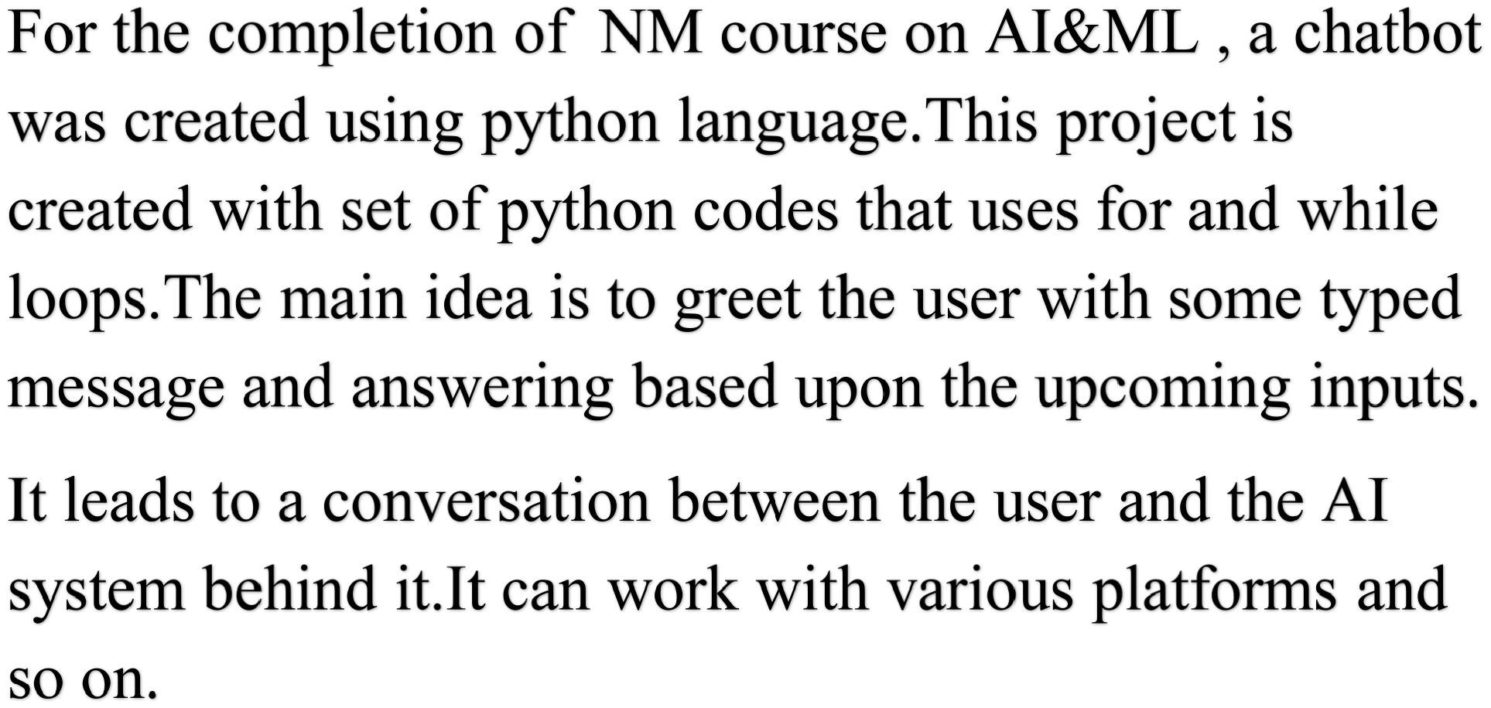

# INDEX

|  |  |  |
| --- | --- | --- |
| **Sr. No.** | **Table of Contents** | **Page No.** |
| 1 | Chapter 1: Introduction |  |
| 2 | Chapter 2: Services and Tools Required |  |
| 3 | Chapter 3: Project Architecture |  |
| 4 | Chapter 4: Project Outcome |  |
| 5 | Conclusion |  |
| 6 | Future Scope |  |
| 7 | References |  |
| 8 | Code |  |

**CHAPTER 1**

**INTRODUCTION**

## 1.1 Problem Statement

To create a chatbot using ChatGPT as project using python language.

**1.2 Proposed solution**

A chat bot was created using python.

**1.3 Feature**

User can start chatting with typed messages.

**1.4Advantages**

Used in various platforms as basic code.

**1.5. Scope**

Automation of customer queries.

## 1.6 Future work

Use it for educational purposes.

**CHAPTER 2**

**SERVICES AND TOOLS REQUIRED**

**2.1 Services Used**

**1.INTERNET**

**2.2 Tools and Software used**

**1.CHATGPT**

**2.PYTHON**

# CHAPTER 3

**PROJECT ARCHITECTURE**

## 3.1 Architecture

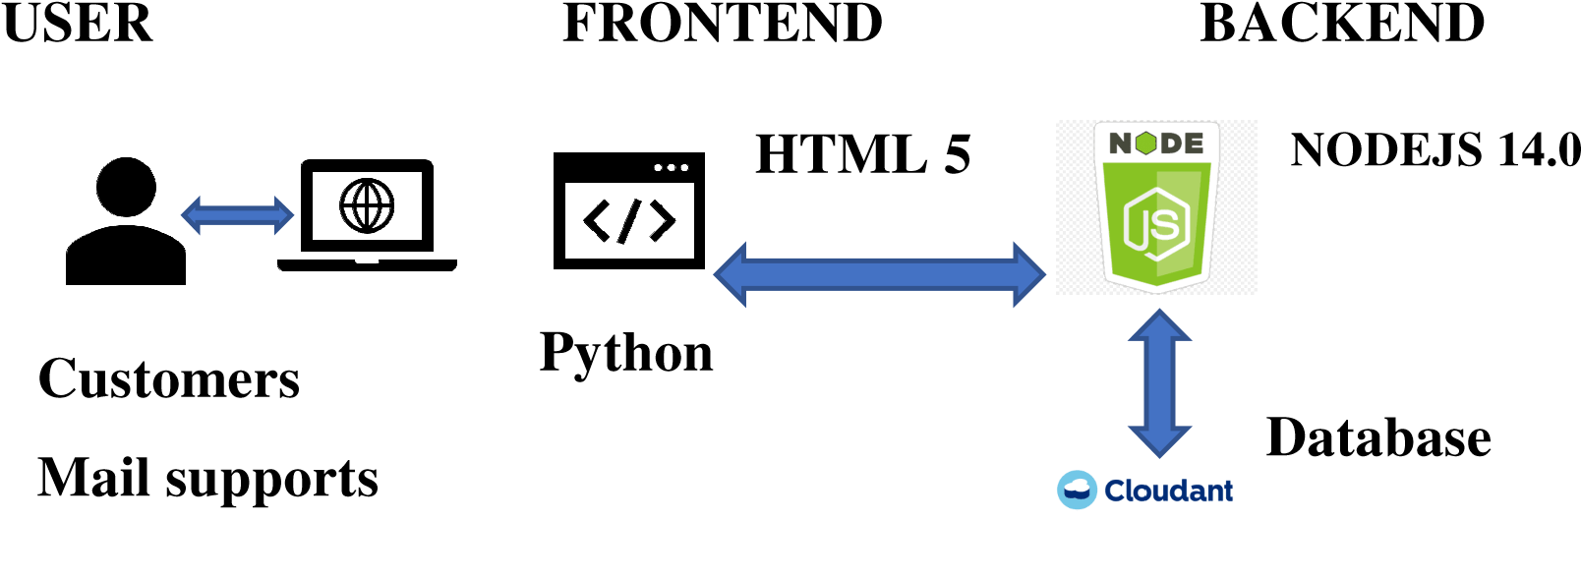

# CHAPTER 4 PROJECT OUTCOME

# 

**FUTURE SCOPE**

**QUERY AUTOMATION**

**DOUBT CLEARING IN EDUCATION**

**REFERENCES**

**https://chat.openai.com/**

# CODE

**Please Provide Code through Git Hub Repo Link**

**import random**

**# Define a dictionary of responses**

**responses = {**

**"hello": ["Hello!", "Hi there!", "Hey!"],**

**"how_are_you": ["I'm doing well, thank you!", "I'm good, thanks for asking!", "All good here!"],**

**"default": ["I'm not sure how to respond to that.", "Could you please rephrase?", "Sorry, I didn't get that."]**

**}**

**# Define a function to generate a response based on input**

**def generate_response(message):**

**message = message.lower()**

**if message.startswith("hello") or message.startswith("hi"):**

**return random.choice(responses["hello"])**

**elif "how are you" in message:**

**return random.choice(responses["how_are_you"])**

**else:**

**return random.choice(responses["default"])**

**# Example usage**

**user_input = input("You: ")**

**response = generate_response(user_input)**

**print("Bot:", response)**